Exercise 1,2,3,5

<!DOCTYPE html>

<html lang="en">

<head>

    <meta charset="UTF-8">

    <meta name="viewport" content="width=device-width, initial-scale=1.0">

    <title>My First HTML Page</title>

    <style>

        #intro {

            border: 2px solid black;

            padding: 10px;

        }

        .highlight {

            background-color: yellow;

        }

    </style>

</head>

<body>

    <h1>Jayatheertha S G</h1>

    <p>I enjoy reading, painting and playing cricket during free time.</p>

    <hr>

    <br>

    <h2>My Favorite Fruits</h2>

    <ul>

        <li>Mango</li>

        <li>Apple</li>

        <li>Banana</li>

    </ul>

    <h2>Top 3 Movies</h2>

    <ol>

        <li>KGF-1</li>

        <li>Kantara-2</li>

        <li>Ugram</li>

    </ol>

    <p>

        Visit my favorite website:

        <a href="https://www.wikipedia.org/" target="_blank">wikipedia</a>

    </p>

    <h2>My Favorite Image</h2>

    <img src="https://media.istockphoto.com/id/1441441771/photo/investment-concept-stacked-coins-with-a-background-monitor-showing-data-graphs-with-an-arrow.jpg?s=612x612&w=0&k=20&c=zY2TwBnieCKyp8Ykl1A1z5jmv9NHnqyeVqBumAQcppY=" alt="Placeholder Image">

    <h2>Student Details</h2>

    <table border="1">

        <tr>

            <th>Student Name</th>

            <th>Age</th>

            <th>Favorite Subject</th>

        </tr>

        <tr>

            <td>Jayatheertha S G</td>

            <td>24</td>

            <td>Mathematics</td>

        </tr>

        <tr>

            <td>Sagar</td>

            <td>21</td>

            <td>Physics</td>

        </tr>

        <tr>

            <td>Parinith</td>

            <td>22</td>

            <td>Computer Science</td>

        </tr>

    </table>

    <br>

    <div id="intro">

        This is the intro section with a border and padding.

    </div>

    <br>

    <div class="highlight">

        This section is highlighted with a yellow background.

    </div>

</body>

</html>

Output:



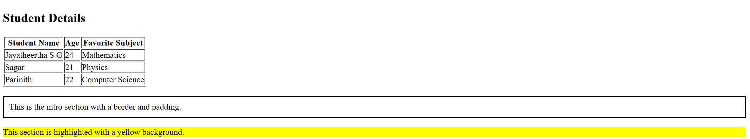

Exercise 4

<!DOCTYPE html>

<html lang="en">

<head>

    <meta charset="UTF-8">

    <meta name="viewport" content="width=device-width, initial-scale=1.0">

    <title>My First HTML Page</title>

    <style>

        h1 {

            background-color: lightblue;

            color: darkblue;

            font-size: 30px;

        }

        p{

            font-family: Arial;

            text-align: justify;

        }

    </style>

</head>

<body>

<h1>Jayatheertha S G</h1>

<p>Lorem ipsum dolor sit amet consectetur adipisicing elit. Magni dolorum, sunt nulla alias omnis blanditiis quidem nobis ea libero quibusdam, fuga similique, neque consequatur incidunt aliquid autem? Ipsam, a suscipit.</p>

</body>

</html>

Output:

